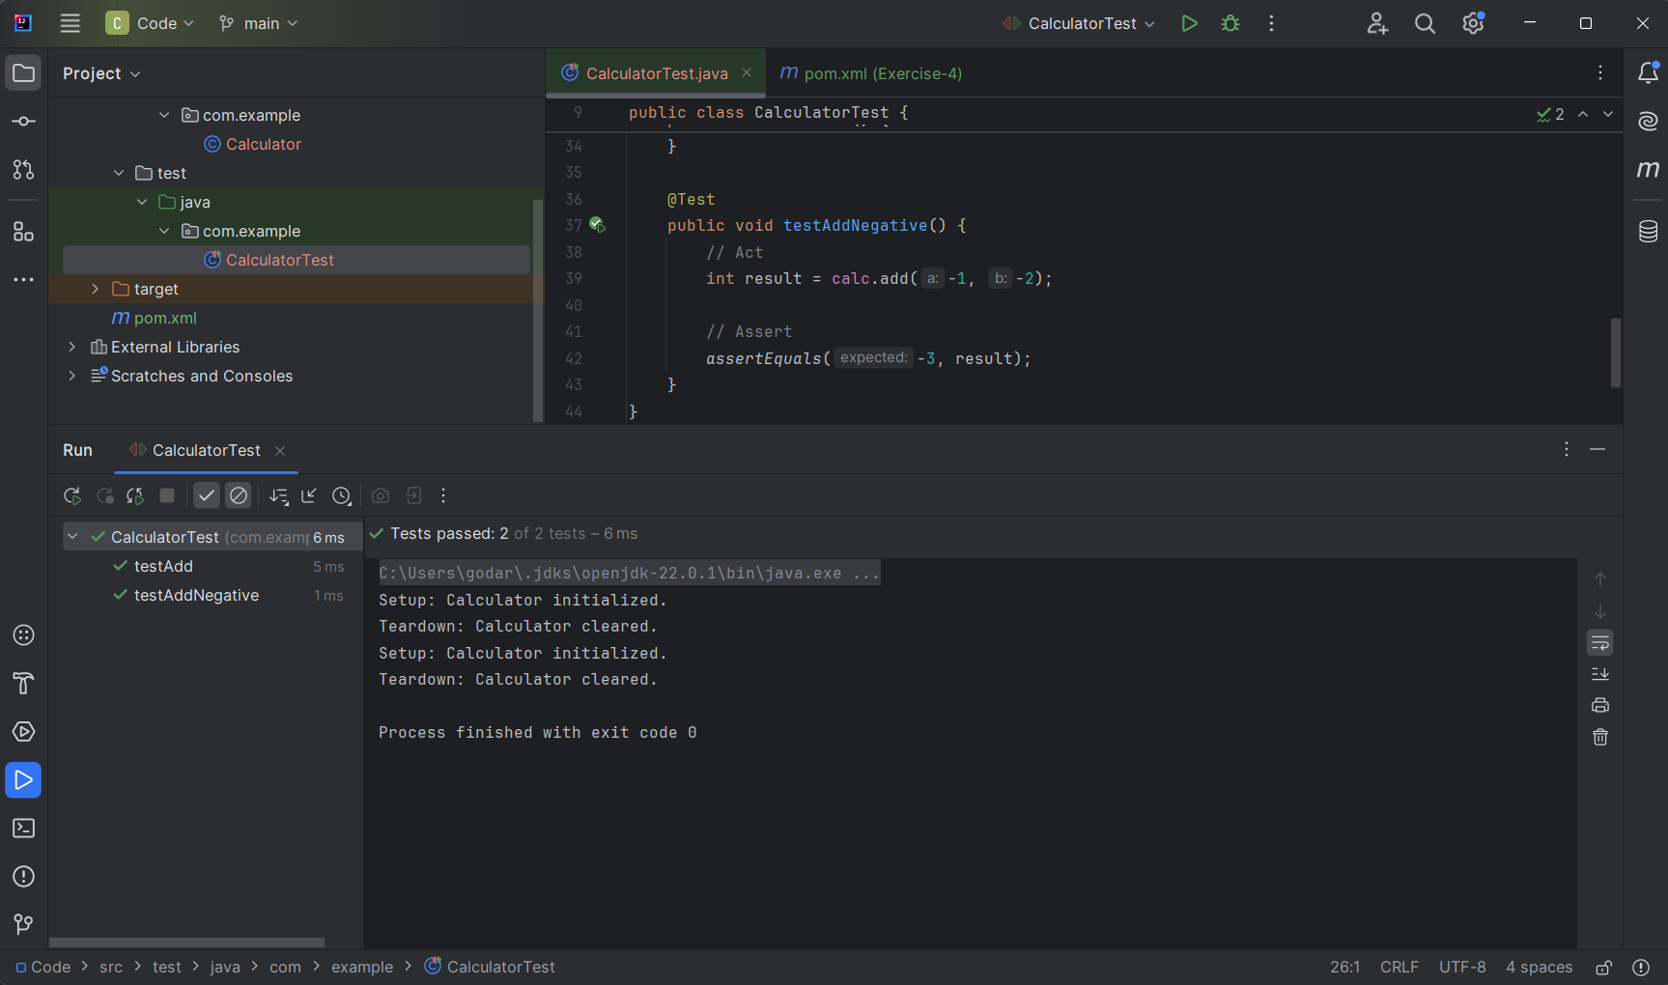**Terminal Output:**

C:\Users\godar\.jdks\openjdk-22.0.1\bin\java.exe -ea -Didea.test.cyclic.buffer.size=1048576 "-javaagent:C:\Program Files\JetBrains\IntelliJ IDEA Community Edition 2024.1.1\lib\idea_rt.jar=54158:C:\Program Files\JetBrains\IntelliJ IDEA Community Edition 2024.1.1\bin" -Dfile.encoding=UTF-8 -Dsun.stdout.encoding=UTF-8 -Dsun.stderr.encoding=UTF-8 -classpath "C:\Program Files\JetBrains\IntelliJ IDEA Community Edition 2024.1.1\lib\idea_rt.jar;C:\Program Files\JetBrains\IntelliJ IDEA Community Edition 2024.1.1\plugins\junit\lib\junit5-rt.jar;C:\Program Files\JetBrains\IntelliJ IDEA Community Edition 2024.1.1\plugins\junit\lib\junit-rt.jar;C:\Users\godar\OneDrive\Desktop\Cognizant Deep Skilling\Week-2-JUnit_Mockito_SL4J_and_PL-SQL\JUnit_Mockito_and_SL4J\JUnit_Basic\Exercise-4-AAA_Pattern_Test Fixtures_Setup_and_Teardown_Methods_in_JUnit\Code\target\test-classes;C:\Users\godar\OneDrive\Desktop\Cognizant Deep Skilling\Week-2-JUnit_Mockito_SL4J_and_PL-SQL\JUnit_Mockito_and_SL4J\JUnit_Basic\Exercise-4-AAA_Pattern_Test Fixtures_Setup_and_Teardown_Methods_in_JUnit\Code\target\classes;C:\Users\godar\.m2\repository\junit\junit\4.13.2\junit-4.13.2.jar;C:\Users\godar\.m2\repository\org\hamcrest\hamcrest-core\1.3\hamcrest-core-1.3.jar" com.intellij.rt.junit.JUnitStarter -ideVersion5 -junit4 com.example.CalculatorTest

Setup: Calculator initialized.

Teardown: Calculator cleared.

Setup: Calculator initialized.

Teardown: Calculator cleared.

Process finished with exit code 0  
  
  
**testAdd()**Setup: Calculator initialized.

Teardown: Calculator cleared.  
  
**testAddNegative()**

Setup: Calculator initialized.

Teardown: Calculator cleared.